

**DEPARTMENT OF CENTRE OF EXCELLENCE**

**CODENTINE ’23**

**1.** Sam is a qualified bachelor. He makes the decision to start a family and settle down in life. He searches for a bride. He wants to wed a woman who possesses at least one of the following eight attributes :-

1. The girl should be rich.
2. The girl should be an Engineer/Doctor.
3. The girl should be beautiful.
4. The girl should be of height 5.3″.
5. The girl should be working in an MNC.
6. The girl should be an extrovert.
7. The girl should not have spectacles.
8. The girl should be kind and honest.

He is in search of a bride who has some or all of the 8 qualities mentioned above. On bride hunting, he may find more than one contenders to be his wife.

In that case, he wants to choose a girl whose house is closest to his house. Find a bride for Sam who has maximum qualities. If in case, there are more than one contenders who are at equal distance from Sam’’s house; then

* **print ““Polygamy not allowed””.**

In case there is no suitable girl who fits the criteria then

* **print “”No suitable girl found””**

Given a Matrix N*M, Sam’s house is at (1, 1). It is denoted by 1. In the same matrix, the location of a marriageable Girl is also denoted by 1. Hence 1 at location (1, 1) should not be considered as the location of a marriageable Girl’s location.

The qualities of that girl, as per Sam’’s criteria, have to be decoded from the number of non-zero neighbors (max 8-way) she has. Similar to the condition above, 1 at location (1, 1) should not be considered as the quality of a Girl. See Example section to get a better understanding.

Find Sam, a suitable Bride and print the row and column of the bride, and find out the number of qualities that the Bride possesses.

NOTE: – Distance is calculated in number of hops in any direction i.e. (Left, Right, Up, Down and Diagonal)

**Constraints**

* 2 <= N,M <= 10^2

**Input Format**

* First Line contains the row (N) and column (M) of the houses.
* Next N lines contain the data about girls and their qualities.

**Output**

* It will contain the row and column of the bride, and the number of qualities that Bride possess separated by a colon (i.e. :).

**Explanation**

**Example 1**

**Input**:

6 6

1 0 0 0 0 0

0 0 0 0 0 0

0 0 1 1 1 0

0 0 1 1 1 0

0 0 1 1 1 0

0 0 0 0 0 0

**Output**:

4:4:8

**Explanation**:

The bride and qualities are present at (3,3),(3,4),(3,5),(4,3),(4,4),(4,5),(5,3),(5,4),(5,5)

* The Bride present at (3,3) has 3 qualities (i.e. (3,4),(4,3) and (4,4)).
* The Bride present at (3,4) has 5 qualities.
* The Bride present at (3,5) has 3 qualities.
* The Bride present at (4,3) has 5 qualities.
* The Bride present at (4,4) has 8 qualities.
* The Bride present at (4,5) has 5 qualities.
* The Bride present at (5,3) has 3 qualities.
* The Bride present at (5,4) has 5 qualities.
* The Bride present at (5,5) has 3 qualities.

**2. Print the following pattern**.

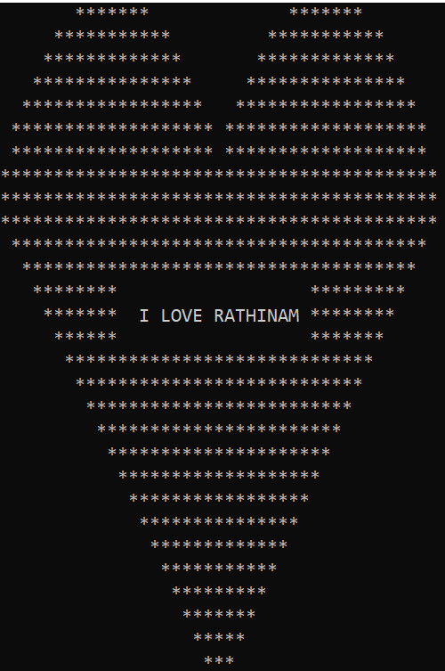

**3. Love calculator using FLAMES:**

**FLAMES**is a popular game named after the acronym: Friends, Lovers, Affectionate, Marriage, Enemies, Sibling. This game does not accurately predict whether or not an individual is right for you, but it can be fun to play this with your friends.  
There are two steps in this game:

* Take the two names.
* Remove the common characters with their respective common occurrences.
* Get the count of the characters that are left .
* Take FLAMES letters as [“F”, “L”, “A”, “M”, “E”, “S”]
* Start removing letter using the count we got.
* The letter which last the process is the result.

**Example :** 

**Input:** Player1 = AJAY, Player2 = PRIYA

**Output:** Friends

4. Sana and Chitti are in the lab. Sana is the recipient of a message from Chitti. He can't, however, send it immediately. Sana is using computer n, while Chitti is using computer 1. The computers are now linked together in a chain. The first is linked to the second, who is linked to the third, and so on. Now all computers between 1 and n (inclusive) should be on so that Sana can view the message. These devices, however, are magical. The first computer has a source attached. There is also a main button (for electricity). When the button is clicked, all of the computers that are linked to the source will toggle (be switched on if it was off, and off if it was on). If and only if every computer before it is turned on, a computer is linked to the source. All computers, including those belonging to Chitti and Sana, are initially turned off. The button has now been pressed k times. Please let me know if Sana can read the message or not. Like in the beginning, all computers are off. The first time the button is pressed, the computer will turn on. When the button is pressed a second time, the first time turns off and the second time turns on. When the button is pressed a third time, the first computer will turn on and the second will stay on (since it wasn't connected to the source because the first computer was off), and so on.

**Input**

1st line will contain t(no. of test cases). Next t lines will contain two integers n(no. of computers) and k(no. of times main button is clicked.

**Output**

t lines containing "YES" or "NO" for each test case.

**Sample Input Sample output**

4

1 0 NO

1 1 YES

4 0 NO

4 47 YES